**VirtualKeyDemo – Virtual Key for Repositories**

This document contains sections for:

* Sprint planning and Task completion
* Core concepts used in project
* Flow of the Application.
* Conclusions

The code for this project is hosted at **https://github.com/raghu2598/VirtualKeyDemo.git**

The project is developed by Raghavendra DC.

## Sprints planning and Task completion

The project is planned to be completed in 1 sprint. Tasks assumed to be completed in the sprint are:

* Creating the flow of the application
* Initializing git repository to track changes as development progresses.
* Writing the Java program to fulfill the requirements of the project.
* Testing the Java program with different kinds of User input
* Pushing code to GitHub.
* Creating this specification document highlighting application capabilities, appearance, and user interactions.

## Core concepts used in project

Collections framework, File Handling, Sorting, Flow Control, Recursion, Exception Handling, Streams API

## Flow of the Application

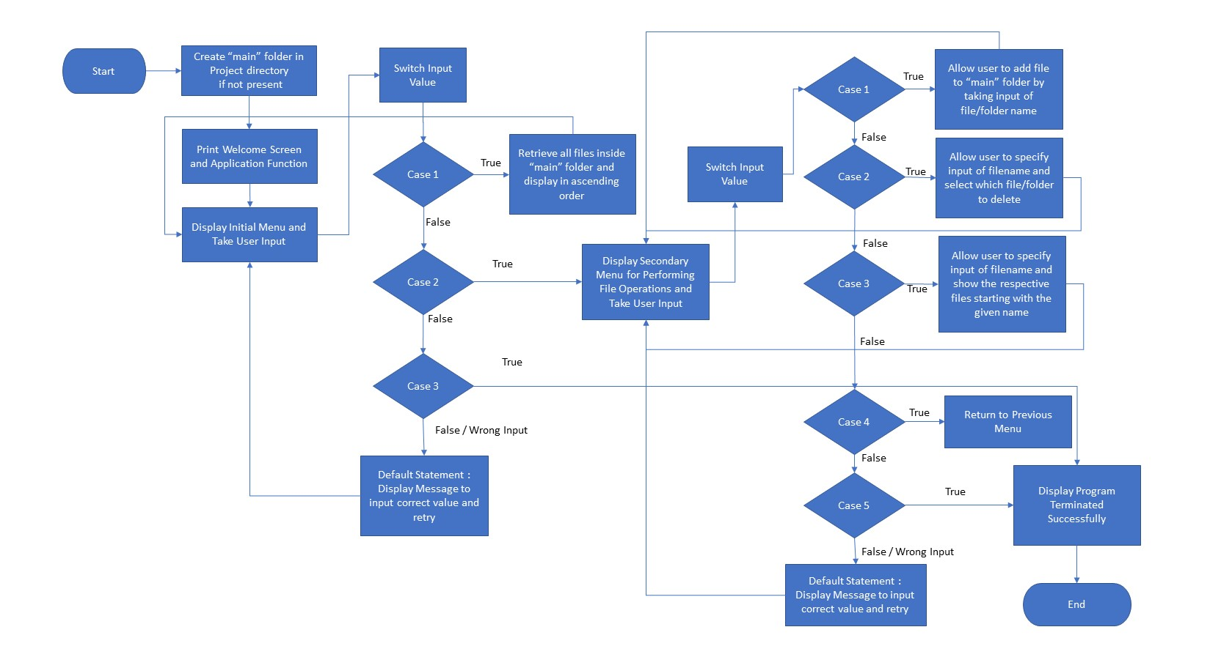



## **Step 6:** Pushing the code to GitHub repository

* Open your command prompt and navigate to the folder where you have created your files.

**cd <folder path>**

* Initialize repository using the following command:

**git init**

* Add all the files to your git repository using the following command:

**git add .**

* Commit the changes using the following command:

**git commit . -m <commit message>**

* Push the files to the folder you initially created using the following command:

**git push -u origin master**

## Conclusions

Further enhancements to the application can be made which may include:

* Conditions to check if user is allowed to delete the file or add the file at the specific locations.
* Asking user to verify if they really want to delete the selected directory if it’s not empty.
* Retrieving files/folders by different criteria like Last Modified, Type, etc.
* Allowing user to append data to the file.